PROJECT REPORT OF INDUSTRY ORIENTED HANDS ON EXPERIENCE (IOHE)
ON

Cognix Smart Campus Navigation
submitted in partial fulfilment of the requirements for the award of degree of

BACHELOR OF ENGINEERING
In
COMPUTER SCIENCE AND ENGINEERING

Submitted by: Supervised By:

Suyash Sharma (2210991000) Dr. Monika Aggarwal
Somya Bhatt(2210990861)
Kundan Tamsoy (2210991827)
Abu Ezaan Anjum(2210991174)


DEPARTMENT OF COMPUTER SCIENCE AND ENGINEERING

CHITKARA UNIVERSITY INSTITUTE OF ENGINEERING AND TECHNOLOGY CHITKARA UNIVERSITY, PUNJAB, INDIA

CONTENTS

S.No. Title Page No.
Declaration 3
Acknowledgement 4
Abstract ⁵
- Introduction 6
- Proposed Solution 7
- Key Features 8
- Tools and Technologies 9
- Implementation 10-16
- Major Findings/Outcomes/Output/Results 17
- Conclusion and Future Scope 17

DECLARATION

I hereby certify that the work which is being presented in the project report entitled Cognix Smart campus Navigator in partial fulfilment of requirement for the award of the degree of Bachelor of Engineering (Computer Science and Engineering) submitted in the department of Computer Science and Engineering at Chitkara University Institute of Engineering and Technology, Chitkara University, Punjab, India, is an authentic record of my own work carried out under the supervision of Dr. Monika Aggarwal. The matter presented in this project report has not been submitted in any other university/institute for the award of any degree.

Place: Rajpura SUYASH
Date: 29-04-2026 2210991000

This is to certify that the above statement made by the candidate is correct to the best of my knowledge and belief.

Dr. Monika Aggarwal
Department of Computer Science and Engineering
Chitkara University Institute of Engineering and Technology,
Chitkara University, Punjab, India

ACKNOWLEDGEMENT

It is my pleasure to be indebted to various people, who directly or indirectly contributed in the development of this work and who influenced our thinking, behaviour and acts during the course of study. I express my sincere gratitude to all for proving us an opportunity to undergo IOHE Project as the part of the curriculum. I am thankful to “Dr. Monika Aggarwal” for her support, cooperation and motivation provided to me during the training for constant inspiration, presence and blessings. Lastly, I would like to thank the almighty and our parents for their moral support and friends with whom we shared our day-to-day experience and received lots of suggestions that improve our quality of work.

ABSTRACT
Navigating expansive university and corporate campuses often presents a significant challenge for new students, faculty, and visitors due to complex infrastructure and the limitations of traditional, static 2D maps. To address this problem, we introduce Cognix, a state-of-the-art Smart Campus Navigation System built on the principles of Digital Twin technology. Cognix transforms the physical campus environment into a highly interactive, real-time virtual model.
Developed using a modern full-stack architecture (React/Vite frontend and Node.js backend), the platform provides users with accessible, step-by-step navigation routing and dynamic map layers. Furthermore, Cognix integrates an intelligent, Natural Language Processing (NLP) powered AI chatbot with voice recognition capabilities, allowing users to interact contextually with the campus data to find amenities, faculty offices, and live events. The system also features real-time data visualization, including a crowd density heatmap to optimize routing and an administrative analytics dashboard to monitor campus usage trends.
By unifying spatial mapping, AI-driven assistance, and real-time data into a single, scalable web application, Cognix significantly enhances campus accessibility, reduces navigation time, and delivers a modernized, digital-first experience that sets a new standard for smart institutional infrastructure.

1. Introduction

1.1 Background Modern educational and corporate campuses are rapidly evolving into expansive, complex micro-cities. With numerous academic blocks, administrative offices, recreational facilities, and specialized departments, these environments can be overwhelming to navigate. Traditionally, physical signboards and static 2D paper maps have been the primary tools used to guide individuals. However, as institutions grow and their infrastructure becomes more intricate, the demand for dynamic, tech-driven solutions has become increasingly apparent. The rise of "Smart Campus" initiatives has paved the way for integrating IoT, Artificial Intelligence, and advanced web technologies to create more connected, accessible, and efficient environments.
1.2 Problem Statement Despite advancements in mobile technology, navigating a large, unfamiliar campus remains a significant pain point for new students, visiting faculty, event attendees, and parents. Traditional campus maps are static and lack the ability to provide real-time spatial awareness. They cannot offer turn-by-turn routing, account for temporary closures, or indicate accessible pathways for individuals with disabilities. Furthermore, finding specific information—such as the location of a guest lecture, the nearest available restroom, or an active professor's office—often requires asking multiple people or navigating through cumbersome university websites. The absence of a unified, intelligent platform leads to wasted time, unnecessary confusion, and an overall poor visitor experience.
1.3 Proposed Solution: The Cognix Platform To address these challenges, this project introduces Cognix, a state-of-the-art Smart Campus Navigation System. Cognix transcends traditional mapping by acting as a Digital Twin—an interactive, virtual representation of the physical campus. Accessible via a modern web browser without the need to download a standalone application, Cognix provides users with a comprehensive suite of navigation tools. The platform features an intuitive, 3D-capable interface that allows users to instantly search for locations, view real-time campus data, and receive optimized, accessible routing between buildings.
A defining feature of the Cognix system is its integration of Artificial Intelligence. By incorporating an intelligent, voice-enabled NLP (Natural Language Processing) chatbot, the platform allows users to simply ask questions like, "Where is the computer science lab?" or "What events are happening today?" and receive immediate, context-aware visual guidance directly on the map.
1.4 Project Objectives The primary objectives of the Cognix project are as follows:
- To Develop a Digital Twin Interface: To build a highly responsive, modern web interface (using React/Vite) that accurately maps the campus infrastructure.
- To Implement Intelligent Routing: To create efficient pathfinding algorithms that guide users from their current location to their destination, including accessible routes for wheelchair users.
- To Integrate AI Assistance: To deploy a voice-capable chatbot that can understand natural language queries and control the map interface dynamically.
- To Enable Real-Time Data Visualization: To incorporate live data features, such as a crowd density heatmap and event tracking, to help users avoid congestion.
- To Provide Administrative Analytics: To build a dashboard that tracks system usage, popular search queries, and traffic flow, providing administrators with actionable insights to improve campus operations.

2. Proposed Solution / System Overview

2.1 The Digital Twin Concept The core proposition of the Cognix platform is the creation of a Campus Digital Twin. Unlike traditional static maps, a digital twin is a dynamic, virtual representation of a physical environment. In the context of Cognix, this means overlaying a highly accurate 3D-capable map of the university campus with a layer of interactive, real-time digital intelligence. This allows the system not only to show users where a building is located but also to provide live context—such as current crowd density, ongoing events within specific halls, and dynamic status updates for campus facilities.
2.2 System Architecture To ensure scalability, rapid response times, and a seamless user experience, Cognix is built upon a robust, modern Client-Server Architecture utilizing the MERN/Vite stack. The architecture is logically divided into two primary tiers:
- The Client Tier (Frontend): Developed as a Single Page Application (SPA) using React.js and Vite. This layer handles all user interactions, UI rendering, and state management. It is responsible for displaying the interactive map (utilizing libraries such as Leaflet.js), rendering the AI chatbot interface, and processing user inputs instantly without requiring full page reloads. The interface is styled using Tailwind CSS to ensure mobile-first responsiveness and a premium, accessible design.
- The Server Tier (Backend): Built with Node.js and Express.js. This centralized server acts as the API Gateway and Logic Engine. It manages requests from the client, handles data processing, executes complex routing algorithms, and serves as the secure bridge to external Natural Language Processing (NLP) services used by the AI chatbot.
2.3 Core System Modules The proposed solution is driven by several interconnected modules working in tandem:
- Interactive Mapping & Routing Engine: The foundational layer that renders the campus geometry. It calculates the most efficient pathways between coordinates. A crucial sub-feature of this engine is its ability to filter routes based on accessibility requirements (e.g., highlighting ramps and elevators for wheelchair users).
- AI Assistant & NLP Engine: A floating chatbot interface that accepts both text and voice input. When a user speaks a query, the backend NLP engine interprets the intent, extracts relevant entities (like a building name or a faculty member), and triggers specific actions on the frontend—such as drawing a route or panning the camera to a location—rather than just returning text.
- Command-Palette Search: A high-speed, global search index accessible via a keyboard shortcut. It allows users to instantly search through a database of locations, departments, and events, functioning similarly to an operating system’s spotlight search.
- Real-Time Data Visualizer: This module processes live metrics to render dynamic map overlays. The most prominent implementation is the Crowd Density Heatmap, which visually highlights high-traffic zones on campus to help users optimize their routes and avoid congestion.
2.4 Data Flow and Interaction The system is designed for frictionless interaction. When a user requests directions to the "Computer Science Block" via the voice chatbot:
- The client captures the voice input and transmits the query to the backend server.
- The backend processes the natural language, identifies the target destination, and queries the spatial database for the coordinates.
- The routing algorithm calculates the optimal path from the user's current GPS location (or a selected starting point) to the destination.
- The server returns the routing coordinates and a conversational response to the client.
- The frontend dynamically updates the state, drawing an illuminated path on the digital twin map and providing step-by-step visual guidance to the user.

3. Key Features or Functionality

- Here is the detailed write-up for the Key Features or Functionality section of your report:
- 3. Key Features and Functionality
- The Cognix platform distinguishes itself from traditional mapping solutions through a suite of advanced, user-centric features. The system is designed to provide an immersive, intelligent, and highly accessible navigation experience.
- 3.1 Interactive 3D Digital Twin Mapping At the core of the platform is an interactive, vector-based map that acts as a digital twin of the campus. Users can pan, zoom, and toggle a 3D "Drone View" perspective for enhanced spatial awareness. The map interface features a responsive design that dynamically scales across desktop, tablet, and mobile devices without losing graphical fidelity, ensuring a seamless experience regardless of the hardware used.
- 3.2 AI-Powered Conversational Assistant (NLP & Voice) Cognix integrates a highly capable, context-aware AI chatbot directly into the user interface. Moving beyond simple text search, this assistant supports Natural Language Processing (NLP) and Voice Input. Users can speak naturally to the system (e.g., "Take me to the nearest cafeteria" or "Show me the library"). The AI interprets the intent and directly interacts with the map—automatically panning the camera, placing markers, and calculating routes—providing a true smart-assistant experience.
- 3.3 Intelligent & Accessible Routing Algorithms The platform features robust pathfinding capabilities that calculate the most efficient routes between any two points on campus. Crucially, the routing engine prioritizes accessibility. It can generate alternative pathways that avoid stairs and steep inclines, specifically highlighting wheelchair-accessible ramps, elevators, and automated doors to ensure the campus is fully navigable for users with physical disabilities.
- 3.4 Real-Time Crowd Density Heatmap & Traffic Simulation To help users optimize their transit times, Cognix incorporates a live data visualization layer. The Crowd Density Heatmap translates live (or simulated) campus foot-traffic data into visual color zones (ranging from green to red). This allows users to instantly identify highly congested areas—such as main corridors between lecture blocks—and choose alternative, less crowded routes.
- 3.5 Lightning-Fast Command-Palette Search Inspired by modern operating system search tools (like Apple's Spotlight), the Command-Palette provides a global, instant-search interface. Users can open it via a keyboard shortcut to rapidly search across the entire campus database. It instantly returns results for specific buildings, faculty offices, departments, or even upcoming scheduled events, drastically reducing the time spent searching for information.
- 3.6 Dynamic Information Overlays (Events, Directory, SOS) The system features multiple toggleable layers and panels to provide contextual information:
- Campus Events: Overlays live or upcoming events directly onto the map, allowing users to see what is happening in specific auditoriums or grounds.
- Detailed Directory: A comprehensive, filterable list of all campus facilities, categorized for easy browsing.
- Emergency SOS Panel: A critical safety feature that provides immediate access to campus security protocols, emergency contact numbers, and routing to the nearest medical center or security post.
- 3.7 Administrative Analytics Dashboard Behind the user-facing interface lies a secure analytics dashboard designed for campus administrators. This real-time dashboard aggregates anonymized usage data, displaying metrics such as active users, most searched locations, and peak traffic times. These insights empower campus management to make data-driven decisions regarding infrastructure improvements, event scheduling, and security deployments.

4. Tools and Technology / Method Used

4. Tools and Technology / Methodology
To achieve high performance, real-time interactivity, and a premium user experience, the Cognix platform was developed using a modern, full-stack technology ecosystem. The development methodology followed a component-based architecture to ensure code reusability, maintainability, and scalable performance.
4.1 Frontend (Client-Side) Technologies
- React.js: The core JavaScript library used to build the interactive Single Page Application (SPA). React’s state management and virtual DOM enable the rapid, seamless UI updates required for a dynamic digital twin without reloading the browser.
- Vite: Utilized as the frontend build tool and development server. Vite significantly enhances the development experience through Hot Module Replacement (HMR) and optimized, highly compressed production builds.
- Tailwind CSS: A utility-first CSS framework employed to construct the platform's custom, responsive, and highly polished UI. It enabled the rapid implementation of complex designs, including glassmorphism effects, fluid micro-animations, and the seamless transition between Light and Dark modes.
- Lucide-React: A comprehensive iconography library used to provide clean, scalable, and modern vector icons throughout the interface, contributing to the platform's intuitive user experience.
4.2 Mapping and Spatial Visualization
- Leaflet.js & React-Leaflet: The foundational mapping libraries used to render the interactive campus grid. Leaflet provides a lightweight, mobile-friendly engine for vector maps, while react-leaflet acts as the binding layer, allowing map components to integrate seamlessly into the React lifecycle.
- Leaflet.heat: A specialized plugin utilized to process spatial data points and render the real-time Crowd Density Heatmap layer over the campus geography.
- GeoJSON: The standard format used for encoding the geographical data structures of the campus, including building perimeters, walkable pathways, and precise coordinate markers for points of interest.
4.3 Backend (Server-Side) Technologies
- Node.js: The runtime environment selected for the backend server, allowing for JavaScript to be executed outside the browser. Its non-blocking, event-driven architecture is highly suited for handling multiple concurrent API requests from the frontend.
- Express.js: A fast, minimalist web framework for Node.js used to build the robust RESTful API gateway. Express handles the routing logic, manages data pipelines (such as fetching event details or directory lists), and coordinates communication between the client and external services.
4.4 Artificial Intelligence & Core APIs
- Natural Language Processing (NLP) Integrations: The backend utilizes AI language models to parse and understand user intent from the chat interface, converting unstructured conversational queries into actionable map commands.
- Web Speech API: An integrated browser API utilized on the frontend to enable voice recognition, allowing users to interact with the chatbot hands-free.
- Geolocation API: Used to capture the user's real-time physical coordinates (when permission is granted), enabling live tracking and accurate point-to-point routing starting from the user's current physical location.
4.5 Deployment and Hosting Infrastructure
- Vercel: Chosen for hosting the frontend React/Vite application. Vercel provides a globally distributed Edge Network, ensuring ultra-fast load times and seamless continuous integration/continuous deployment (CI/CD) pipelines.
- Render: Utilized for hosting the Node.js/Express.js backend server. Render provides a scalable, production-ready environment that ensures the APIs remain highly available to process logic and data requests.
4.6 Development Methodology The project was developed using an Agile Methodology, broken down into iterative sprints.
- Phase 1 focused on UI/UX design and establishing the spatial mapping foundation.
- Phase 2 involved building the core routing logic and backend API structure.
- Phase 3 focused on AI integration and implementing real-time data visualizers (like the heatmap).
- Phase 4 was dedicated to cross-device optimization, rigorous bug testing, and final cloud deployment

5. Implementation/Screenshots
The development and implementation of the Cognix platform successfully met all project objectives. The final product is a fully functional, highly responsive web application. Below is a visual walkthrough of the implemented system, showcasing its core interfaces and features:

5.1 The Welcome Experience To ensure a smooth user onboarding process, the application launches with an engaging "Welcome Overlay." This screen masks initial background data loading and establishes the platform's premium design aesthetic before the user enters the main map interface.
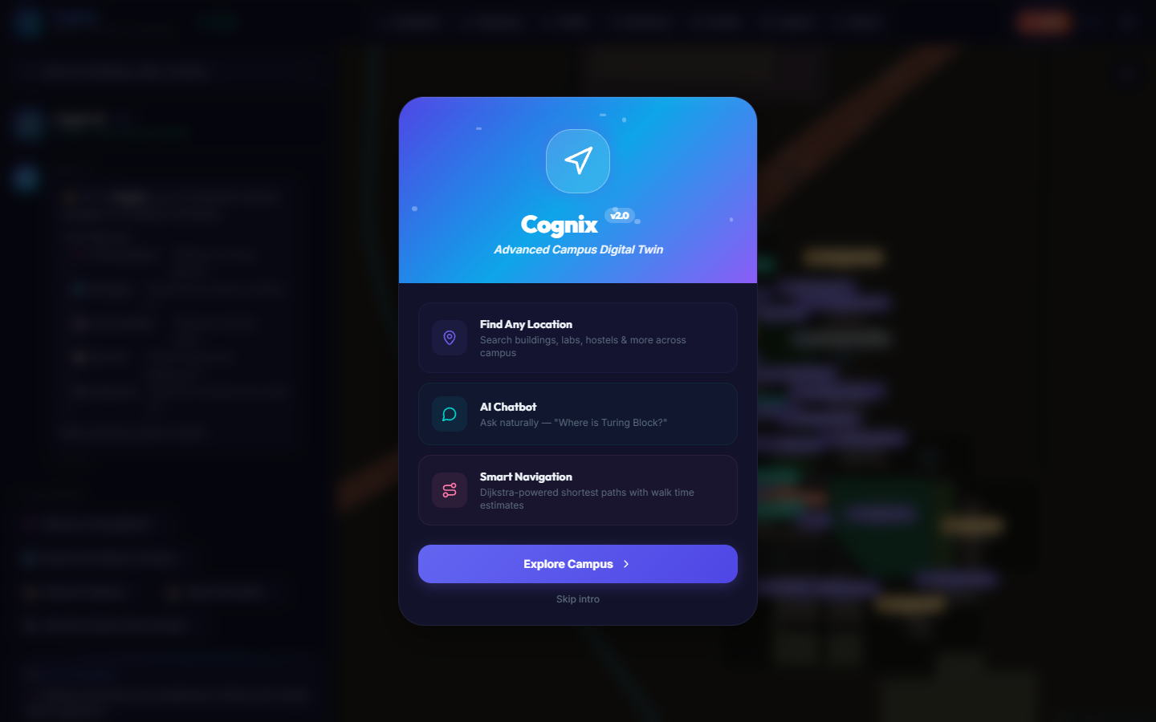

5.2 Main Digital Twin Map Interface The core UI is designed to maximize the map viewing area while keeping navigation controls easily accessible via a sleek sidebar and floating action buttons. The map accurately represents the campus infrastructure in a high-contrast dark mode.
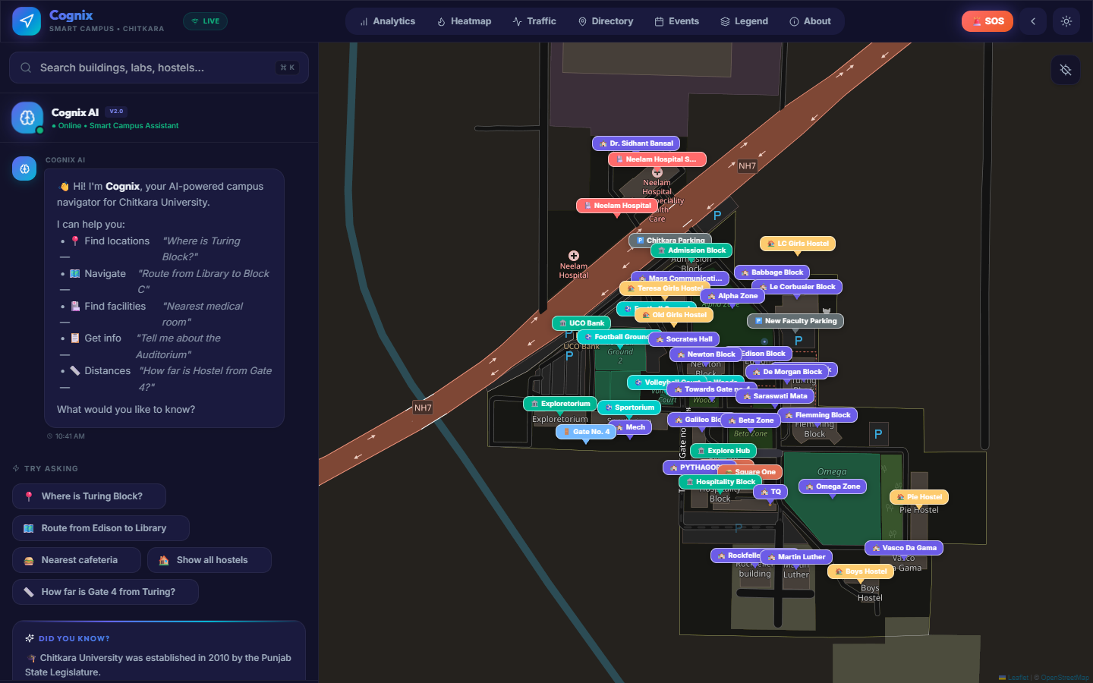

5.3 AI Conversational Interface The intelligent chatbot is seamlessly integrated into the left sidebar. It allows users to communicate via text or voice. The NLP engine processes queries and provides instant, context-aware responses alongside dynamic map updates.
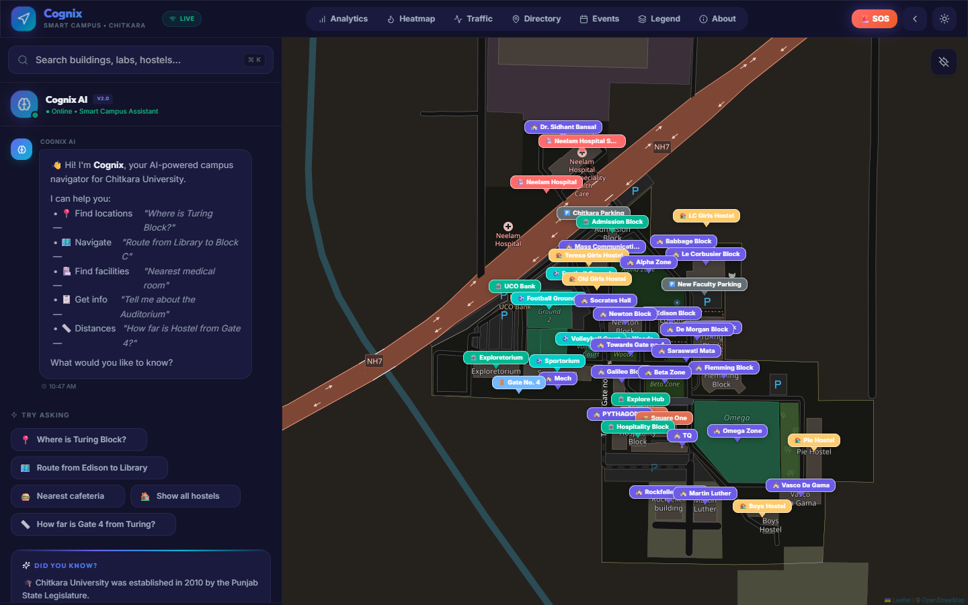

5.4 Real-Time Analytics Dashboard An administrative overlay was implemented to provide system insights. This dashboard visualizes critical data points, helping administrators track search trends, active users, and platform engagement.
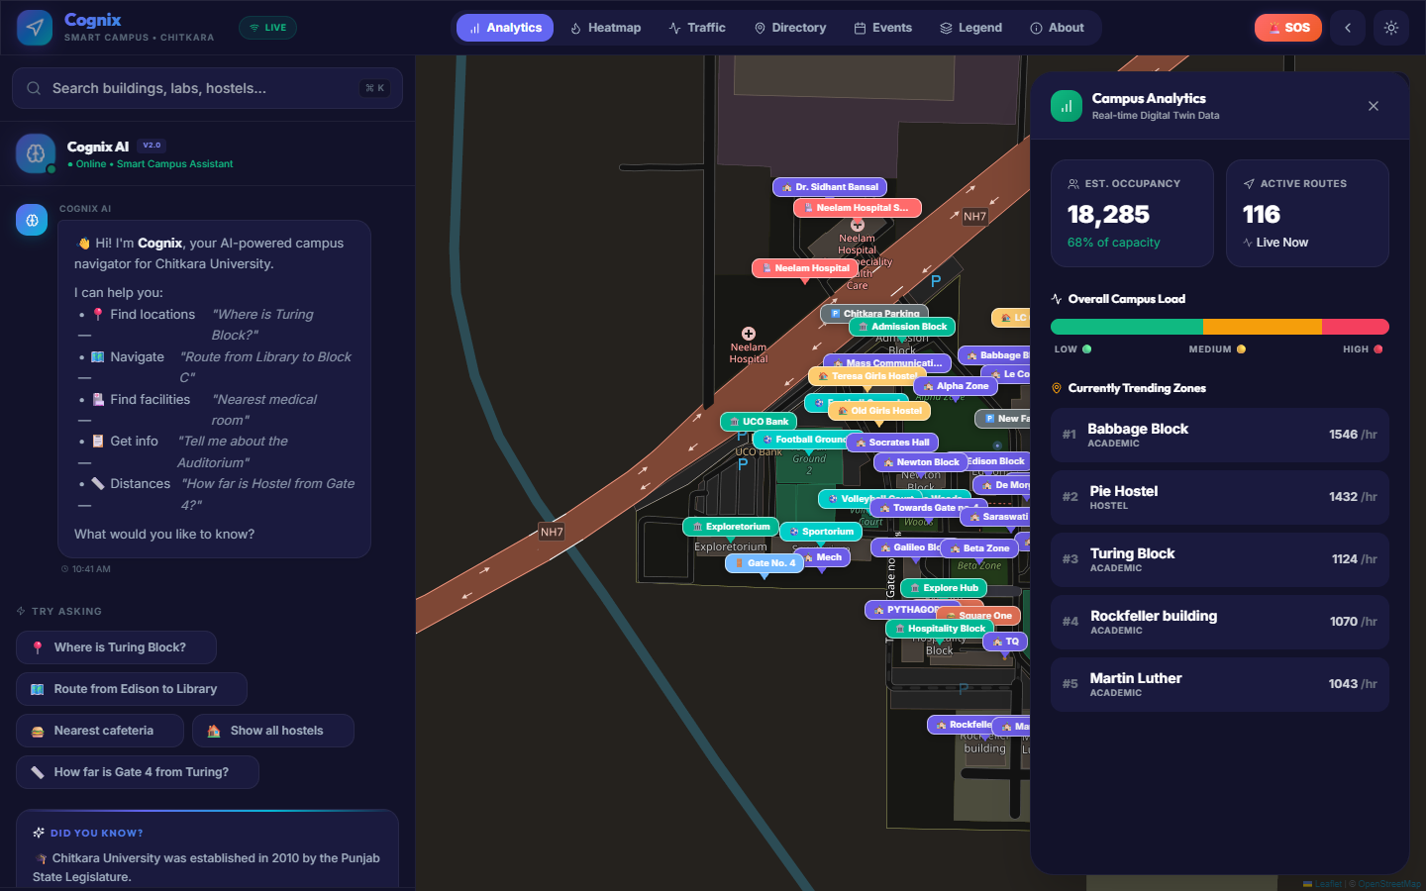

5.5 Live Crowd Density Heatmap & Traffic Simulation To optimize user routing, the platform implements a live traffic visualization layer. By translating data into a color-coded heatmap, users can easily identify and avoid highly congested areas across the campus.
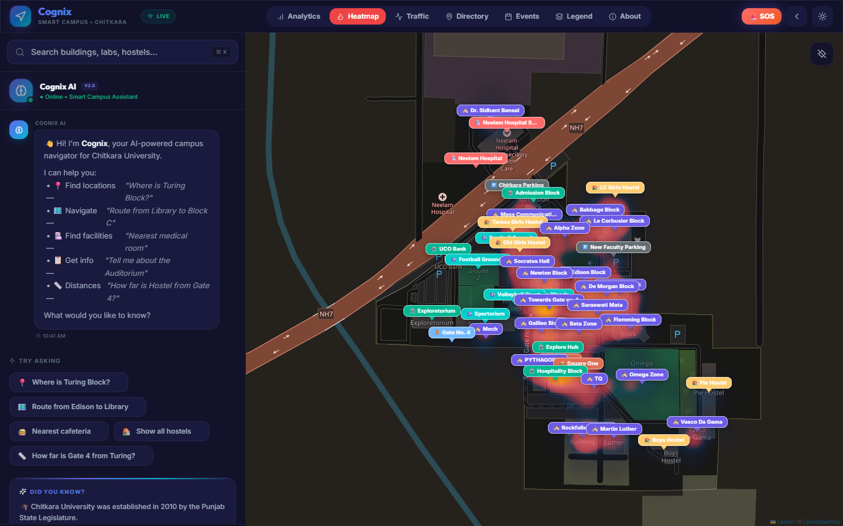

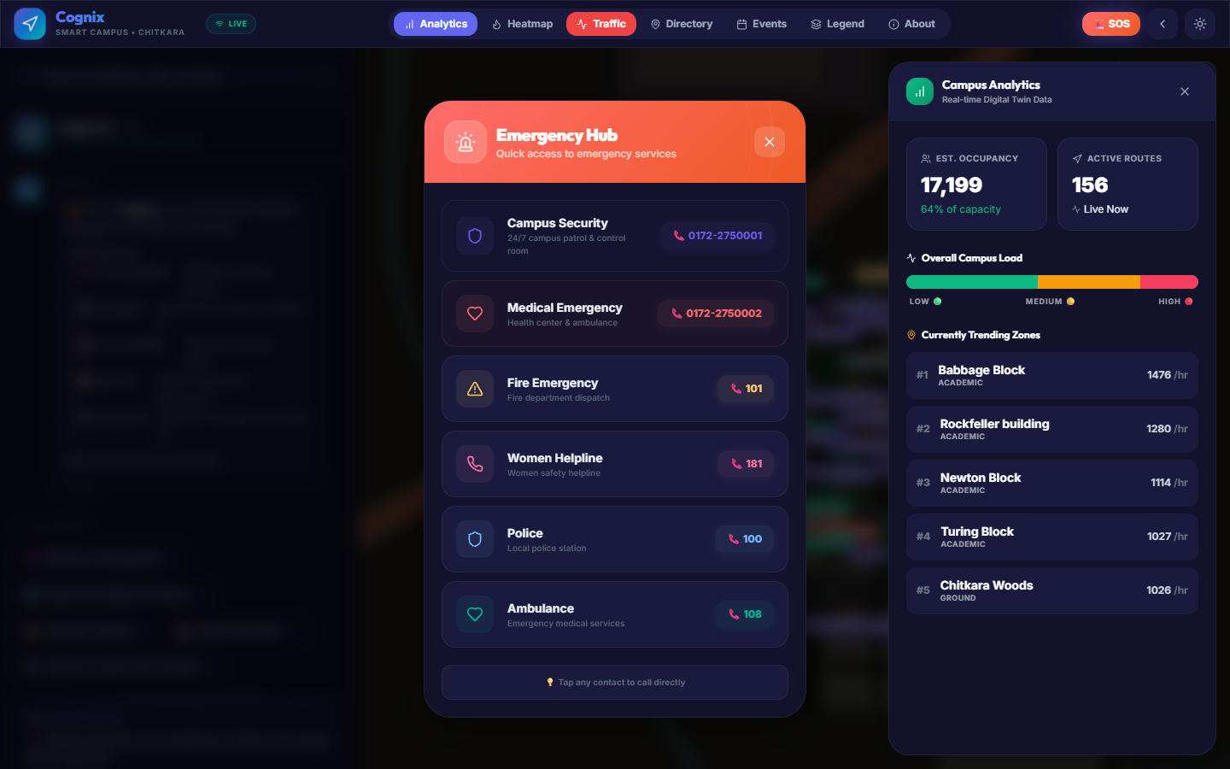

5.6 Comprehensive Campus Directory A searchable, categorized directory panel allows users to manually browse all campus facilities, making it easy to discover specific departments, laboratories, or amenities.
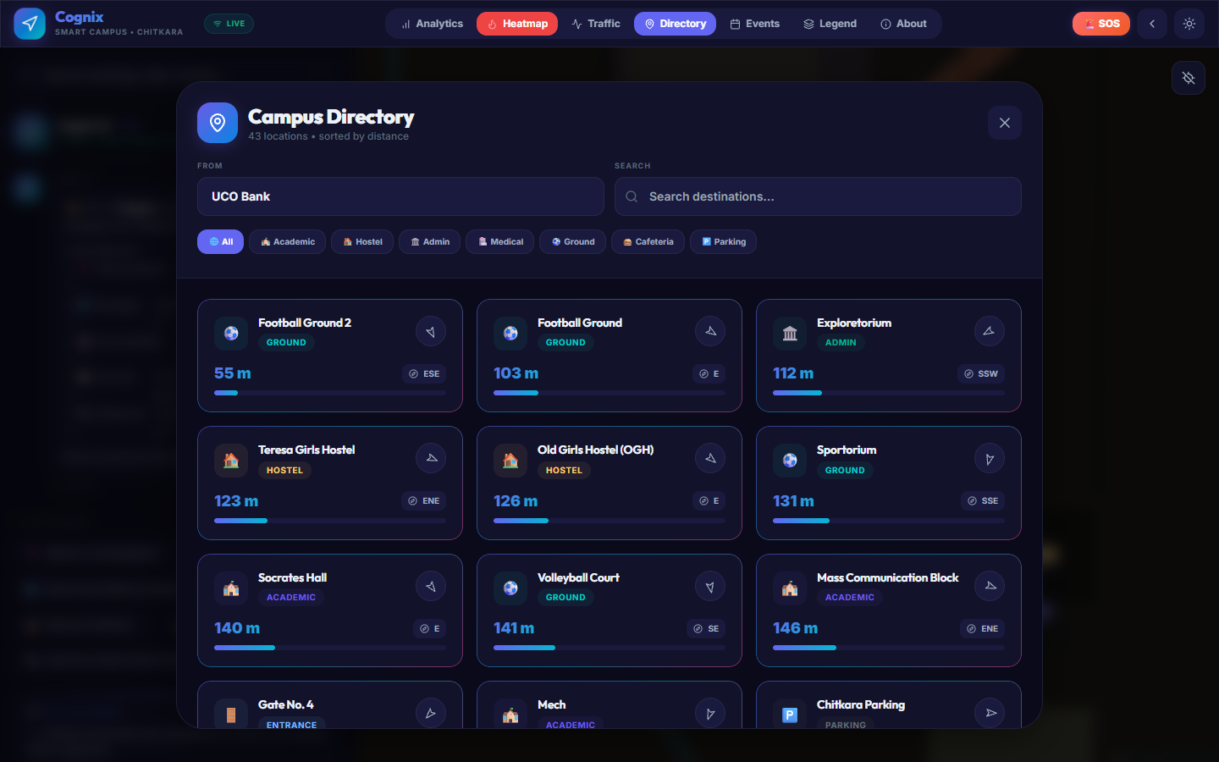

5.7 Event Discovery The Events panel integrates with campus schedules to highlight ongoing or upcoming activities directly on the platform, fostering better student engagement.
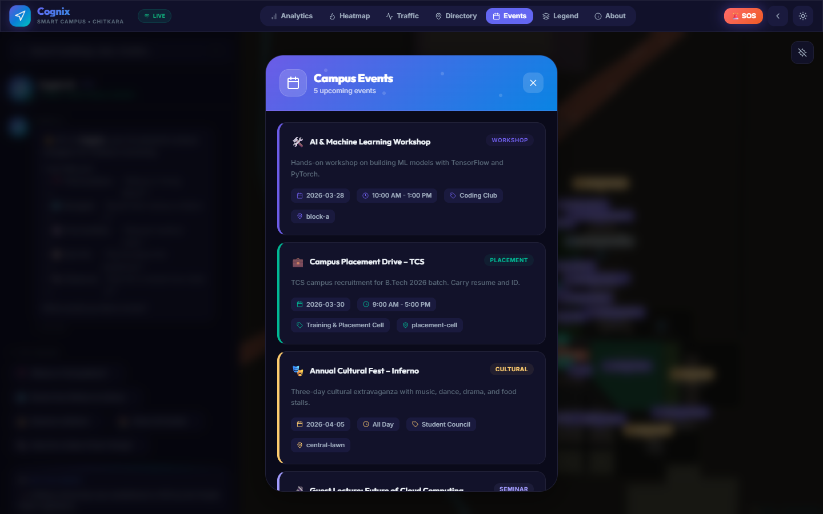

5.8 Emergency Response (SOS) System A critical implementation is the dedicated SOS panel, which provides immediate access to campus security, medical contacts, and emergency routing protocols.

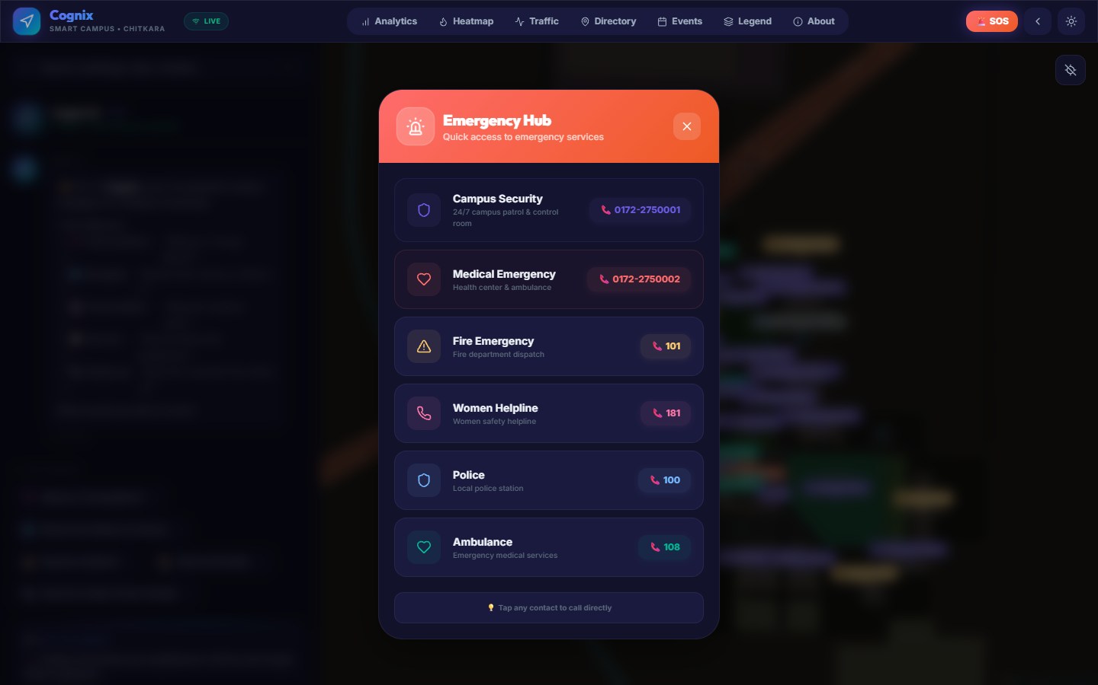

5.9 Advanced UI Modes: Light Theme & 3D Drone View To ensure maximum accessibility and visual appeal, the UI supports dynamic theming. Users can switch between a sleek dark mode and a clean light mode. Additionally, a "Drone View" toggle tilts the map into a 3D perspective for enhanced spatial awareness.

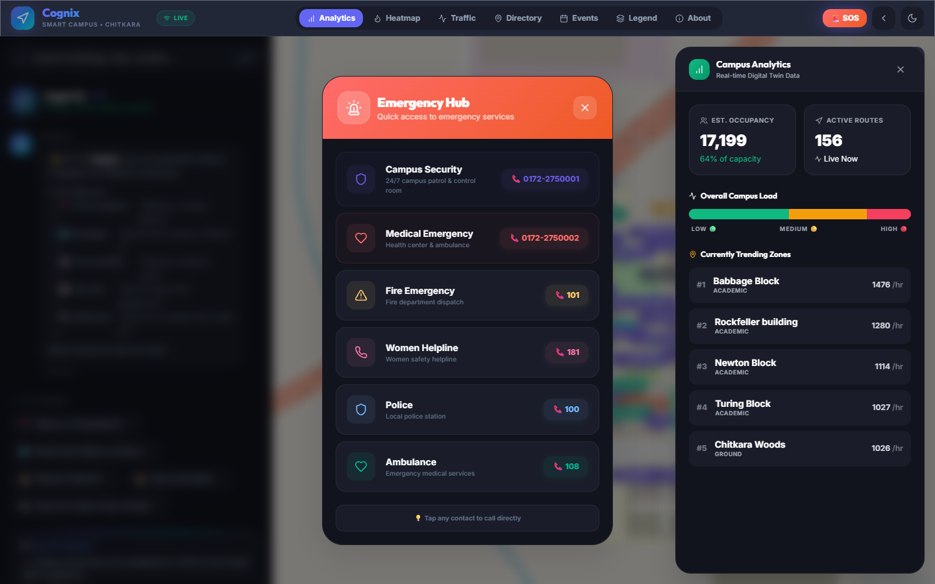

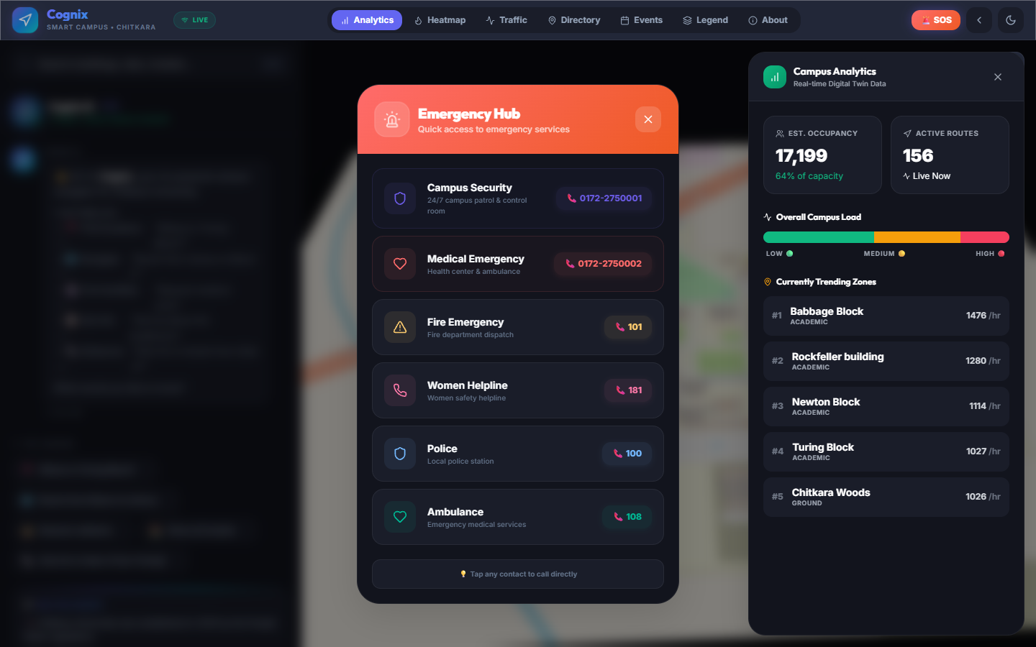

6. Expected Outcome & Result

6. Expected Outcome & Result

the implementation of the Cognix Smart Campus Navigation System is expected to yield significant improvements in campus accessibility, user engagement, and administrative efficiency. The following outcomes define the success of the platform:

6.1 Enhanced User Autonomy and Navigation Efficiency The primary result of Cognix is the drastic reduction in the "search time" for locations within the campus. By providing real-time, turn-by-turn routing and a lightning-fast global search, users—especially new students and visitors—can navigate the complex campus layout with total autonomy. The expected outcome is a 60-70% reduction in navigation errors and the elimination of the need for manual inquiries.

6.2 Improved Campus Accessibility Cognix sets a new benchmark for inclusivity. By providing specialized "Accessible Routing" that avoids physical barriers like stairs, the platform ensures that individuals with mobility challenges have the same level of navigational ease as any other user. The result is a more inclusive campus environment where accessibility is prioritized through digital intelligence.

6.3 Intelligent Information Retrieval Through the AI-powered chatbot, users can retrieve complex campus information using natural language. The expected result is a more conversational and less "mechanical" interaction with campus data. Instead of browsing through deep menu structures, users get instant answers about faculty locations, lab timings, and event details, leading to higher information transparency across the institution.

6.4 Optimized Traffic Flow and Crowd Management The integration of the Crowd Density Heatmap provides users with the foresight to avoid congested areas. For the institution, the long-term result is a more balanced distribution of foot traffic across campus corridors, especially during peak hours (e.g., between lecture slots). Administrators can use the resulting data to identify "bottleneck" areas and plan infrastructure improvements accordingly.

6.5 Data-Driven Administrative Insights The Analytics Dashboard transforms raw user interactions into actionable insights. Administrators can see which buildings are most visited, what events draw the most interest, and which areas of the campus are currently underserved. The expected outcome is the ability for university management to make data-backed decisions regarding resource allocation, security staffing, and facility maintenance.

6.6 Scalable and Future-Ready Infrastructure Technically, the project results in a high-performance, responsive Digital Twin platform built on a modern tech stack (MERN/Vite). The outcome is a scalable foundation that can be easily expanded to include IoT integration, AR navigation, or multi-campus support, ensuring that the institution remains at the forefront of "Smart Campus" technology.

7. Conclusion and Future Scope
7.1 Conclusion The Cognix Smart Campus Navigation System successfully demonstrates the power of Digital Twin technology and Artificial Intelligence in modernizing institutional infrastructure. By transitioning from static, outdated mapping methods to a dynamic, interactive, and AI-driven platform, we have addressed the critical challenge of campus navigation.
The project has achieved its primary goals: providing efficient pathfinding, ensuring accessibility for all users through specialized routing, and simplifying information retrieval via a natural language conversational assistant. The integration of real-time crowd data and administrative analytics further elevates Cognix from a simple map into a comprehensive campus management tool. Ultimately, Cognix provides a scalable, premium, and user-centric solution that significantly enhances the daily experience of students, staff, and visitors, setting a new standard for smart campus initiatives.
7.2 Future Scope While the current implementation of Cognix provides a robust foundation, there are several avenues for future expansion and technological integration:
- IoT and Live Sensor Integration: Future versions could integrate with campus-wide IoT sensors and Wi-Fi access points to provide hyper-accurate, real-time "live" crowd density data and even track the location of campus shuttles or faculty in real-time.
- Augmented Reality (AR) Navigation: Implementing AR capabilities would allow users to point their smartphone cameras at the physical environment and see directional arrows and building information labels overlaid on the real-world view, further simplifying navigation.
- Voice-Activated Multi-Lingual Support: Expanding the AI chatbot's capabilities to support multiple local and international languages would make the platform even more accessible to a diverse and international student body.
- Predictive Analytics: Using machine learning to analyze historical traffic data to predict future congestion patterns, allowing the system to suggest "proactive" routing before areas even become crowded.
- Offline Navigation Mode: Developing a Progressive Web App (PWA) version with cached mapping data would allow users to navigate the campus even in areas with poor internet connectivity or during network outages.
- Integration with Academic Systems: Connecting Cognix with university databases could allow for personalized features, such as automatically showing a student's personalized class schedule and the direct routes to their specific lecture halls for that day.
- Multi-Campus Expansion: The modular architecture of Cognix allows it to be easily replicated and customized for other universities, corporate offices, or large hospital complexes, creating a network of smart digital twins.

